Copyright © ForexGAMETECH2025, All Rights Reserved. ...................................................................................... 4

DISCLAIMER: ................................................................................................................................................. 5

**FOREX BASIC: Learn the Basics of ForexTrading** .......................................................................................... 6

Introduction .................................................................................................................................................. 6

**Forex Basics**: ................................................................................................................................................. 6

Participants: Who plays on the Forex Market? ............................................................................................ 7

Charts and Quotes. ....................................................................................................................................... 8

Am I a Bull or a Bear? .................................................................................................................................. 11

Forex Market Hours .................................................................................................................................... 13

**Forex Language:**.......................................................................................................................................... 14

Bid and Ask Prices… .................................................................................................................................... 14

Spread. ........................................................................................................................................................ 14

Pips and Points. ........................................................................................................................................... 15

Lots and Leverage ....................................................................................................................................... 16

Taking Profits and Stopping Losses ............................................................................................................. 18

**Forex Analysis:** ............................................................................................................................................ 20

**Fundamental Analysis** ................................................................................................................................ 20

**Technical Analysis:** ..................................................................................................................................... 21

Trends and Flats .......................................................................................................................................... 21

Channels ...................................................................................................................................................... 23

Triangle Pattern .......................................................................................................................................... 24

**Sentiment Analysis** ..................................................................................................................................... 24



***Enrollment is now open! Check it out here:***

[**http://www.forexboat.com**](http://www.forexboat.com/)

***See you in class!***

**Kirill Eremenko**

Copyright © ForexBoat 2016, All Rights Reserved.

The right of Kirill Eremenko and ForexBoat Pty Ltd to be identified as the author of the Work has been asserted him in accordance with the Copyright, Designs and Patents Act 1988.

All Rights Reserved. No part of this publication may be reproduced, or transmitted in any form or by any means, electronic or otherwise, without written permission from the author.

DISCLAIMER:

Forexboat Pty Ltd (ABN: 29 609 855 414) a Corporate Authorised Representative (AR No. 001238951) of HLK Group Pty Ltd (ACN: 161 284 500) which holds an Australian Financial Services License (AFSL no. 435746). Any information or advice contained on this website is general in nature only and does not constitute personal or investment advice. We will not accept liability for any loss or damage, including without limitation to, any loss of profit, which may arise directly or indirectly from the use of or reliance on such information. You should seek independent financial advice prior to acquiring a financial product. All securities and financial products or instruments transactions involve risks. Please remember that past performance results are not necessarily indicative of future results

**FOREX A-ZTM: Learn the Basics of ForexTrading**

Introduction

The Forex Market is tough. The majority of people who start trading on the Forex Market accrue losses on their accounts during the first year - it is a competitive and volatile world.

But… we have some encouraging news. For experienced traders, it has been a path to achieving financial freedom by securing profitable trades in the long term.

Nowadays, there are thousands of independent traders living from the Forex Market. Others, are making enough money to pay off their bills, or to pay for an incredible vacation.

But for those of you who are beginners, or for those of you who are struggling to get off the ground, these kinds of images seem very far away. The most important thing now is to find out what YOU can do to get the knowledge to succeed in the Forex Market.

*And that’s where FOREX A-Z can help you.*

Starting to trade successfully on the Forex Market relies on one thing only: LEARN TO READ THE MARKET.

Reading the market will help you to win transactions, manage risk and anticipate losses, which are the key aspects to any successful trading career.

FOREX A-Z is helping traders around the world to learn the Forex Market in an easy and practical way. With consistency and discipline, you are closer to achieving positive results.

The knowledge explained here is all free for you to implement - all you need is to dedicate a few hours of your time.

LET’S DO IT!

Forex Basics:

What is the Forex Market?

Before answering this question, let’s take a look at what FOREX stands for:



Yes, Forex stands for **Foreign Exchange.**

Investopedia defines it as the exchange of one currency for another, or the conversion of one currency into another currency. Foreign Exchange also refers to the global market where currencies are traded virtually around-the-clock. The following image illustrates how you are participating in the Forex Market when you take a vacation from USA to Europe and you use your dollars to buy some euros.

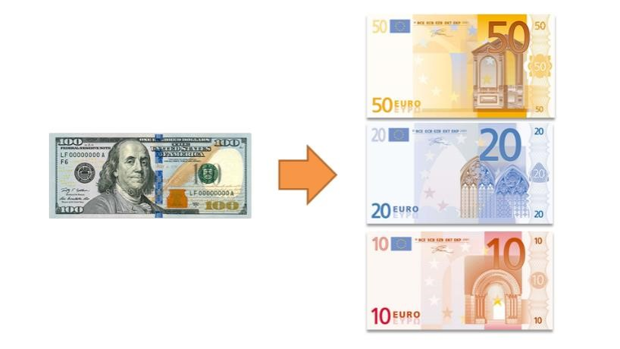

Talking about participants…Who plays on the Forex Market?

Now that you know how can you become a participant in the Forex Market, let’s take a look at who else is playing with you.

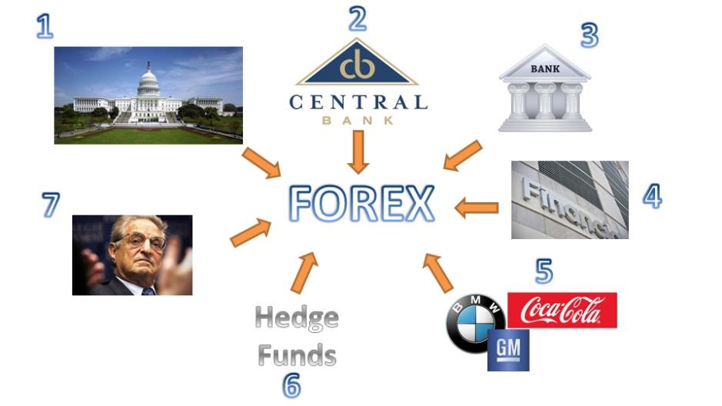

1. Governments: they use the Forex Market to meet certain economic goals.
2. Central Banks: they represent the financial arm of the government; they use the Forex Market to adjust monetary policy.
3. Normal Banks: they trade on the Forex Market to find the correct amount of currencies that they need to develop their activities.
4. Other Financial Institutions: for example, pension funds that invest in the Forex Market to obtain returns in exchange.
5. Multinational Companies: they operate on the Forex Market in order to do transactions between different locations where they are established.
6. Hedge Funds: organizations that are designed to speculate in the Forex Market and obtain a high amount of returns for their investors, in exchange of commissions.
7. Retail Traders: traders such as YOU and I; people who speculate on the Forex Market to make a profit.

You might be wondering… How can Retail Traders get access to the big league?

This is where the concept of a Broker comes into play, a person such as you and me will go to a broker. Their role is to work with other individuals as well, to aggregate all the transactions and send them to the bank, which has direct access to the Forex Market. By this scaling-up process shown in the graph below, a Retail Trader can benefit from the opportunities located in the Forex Market.

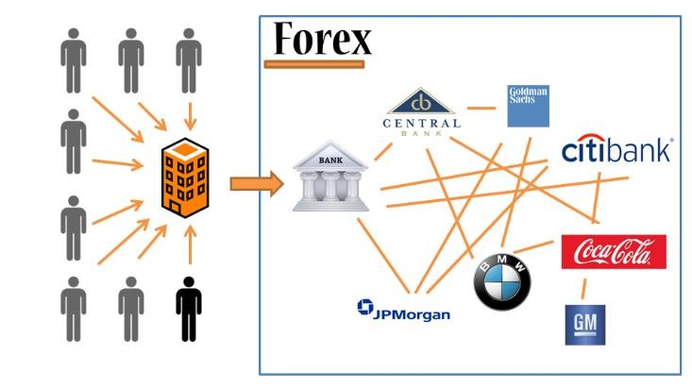

In summary, all these participants mentioned above create a massive volume of money. To be more precise; the volume of the Forex Market is:

**5 TRILLION DOLLARS PER DAY!**

(Equivalent to 26% of NYSE Market Capitalization)

That number is VERY interesting, isn’t it? This high volume represents a vast world of opportunities. You may now be wondering … How can I start?

Well… first we need to read and understand all the topics related to the Forex Market, and in particular, **Charts and Quotes.**

The very basic representation of the market at any point in time is a simple bar and a bar is no more than prices being mapped in a graphical way. A bar always includes what we call O-H-L-C, which stands for Open, High, Low and Close Price.

As you can see in the next graph, the Open price represents the first price of the period with a dash on the left, the High price represents the top of the bar, the Low price represents the bottom of the bar and the Close price is represented with the dash to the right.

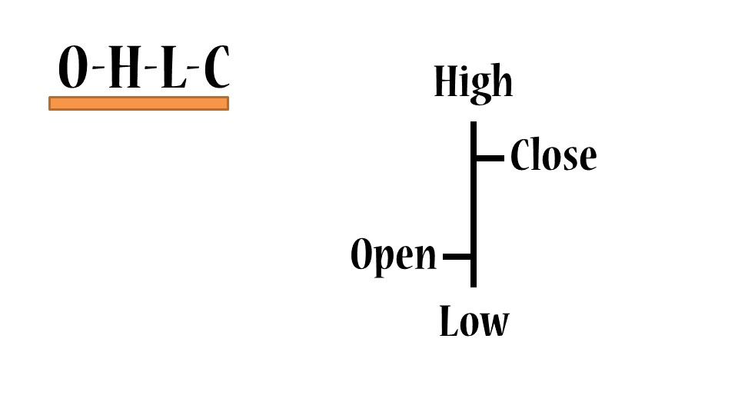

When you assemble a number of these bars, you get a Bar Chart:

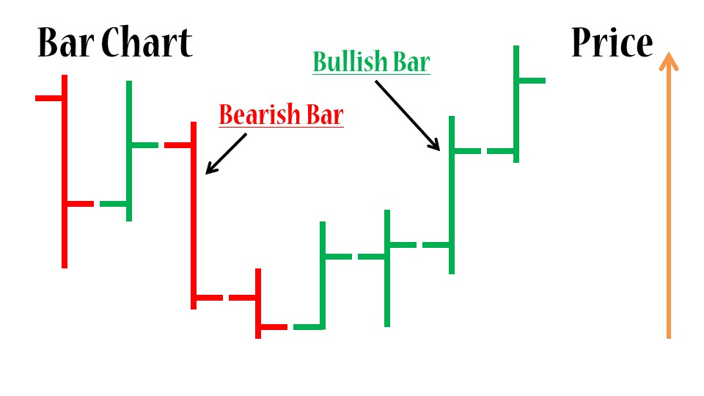

The colors Red and Green help the traders to identify which bars are going up (bullish bars) and which are going down (bearish bars). Don’t worry, we will talk about bullish and bearish bars in one of the next chapters.

The next type of Forex Chart that is very popular among traders is the candle chart. In essence, it carries the same information, but represented differently.

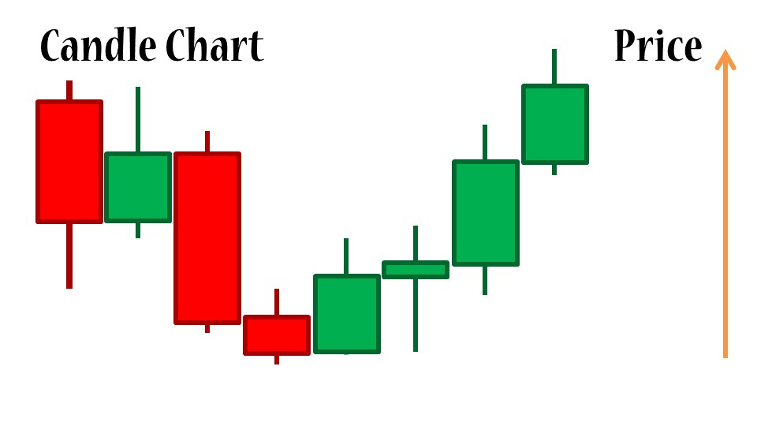

Each of these candles, has a body and two shadows. As in the bars, the Top and Bottom of the shadows represent the High and Low prices. On the other side, the Top and Bottom of the Body represent the Open and Close prices of the period.

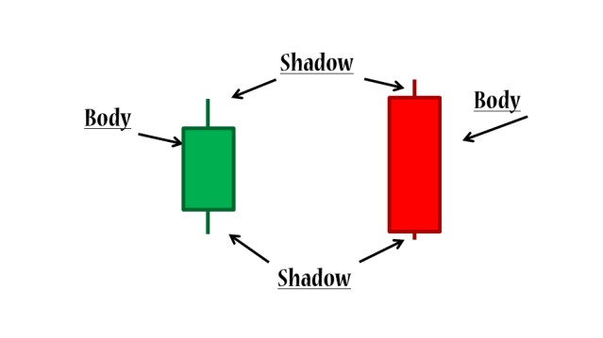

~~Fina~~

Finally, we have the third kind of chart , called a Line Chart. It is the union of the Close price of the periods in the chart.

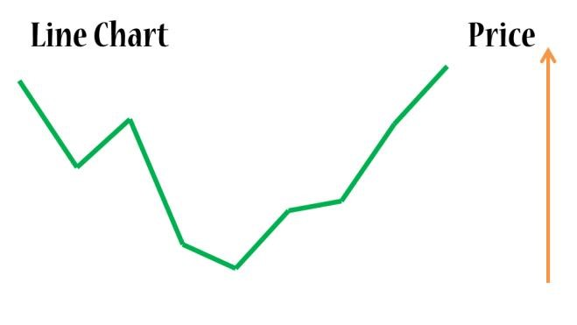

Now that we have a basic understanding of how charts work, let’s take a look at how to read currency pairs in a EURUSD chart. In this case, the base currency is the EUR (Euro) and the quoted currency is the USD (US Dollar). This price means that for every Euro you would get 1.2524 US Dollars. Conversely, to buy 1 Euro you need 1.2524 US Dollars. This chart simply expresses the value of the base currency (on the left), quoted in terms of the quoted currency (on the right).

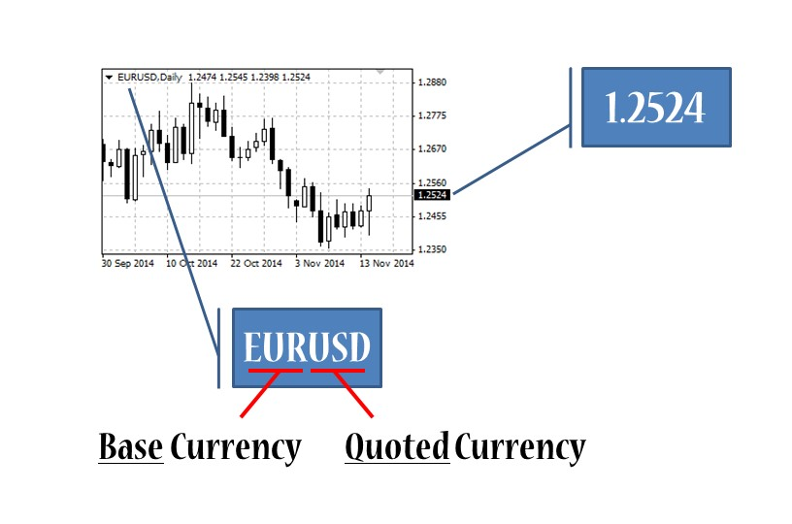

There are over 180 currencies in the world and you can combine them tin different ways o give you a currency pair. Most traders identify 2 groups of currency pairs, shown in the following graph:

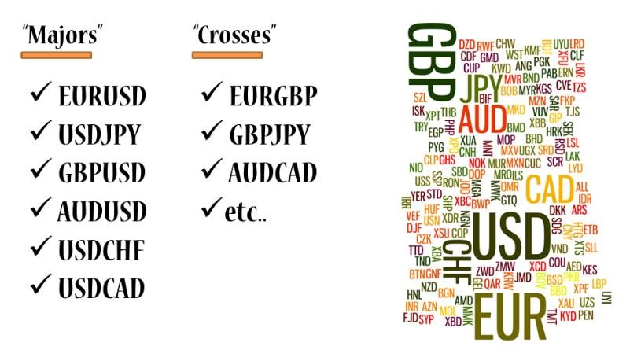

However, there remains an important question to consider.

Am I a Bull or a Bear?

Bulls and bears, are the two animals that dominate the Forex Market. The bulls stand for forex traders that invest in the growth of a currency pair, in this example, the bulls are active buying the pair GBPUSD in order to profit from the growth in the price. On the opposing side, bears are traders that invest in the decline of a currency pair, in this example bears would profit from a downward trend in the EURUSD by selling this currency pair. It is important to mention that YOU, as trader, will act sometimes as a bear and other times as a bull, depending on the market conditions and your strategy.

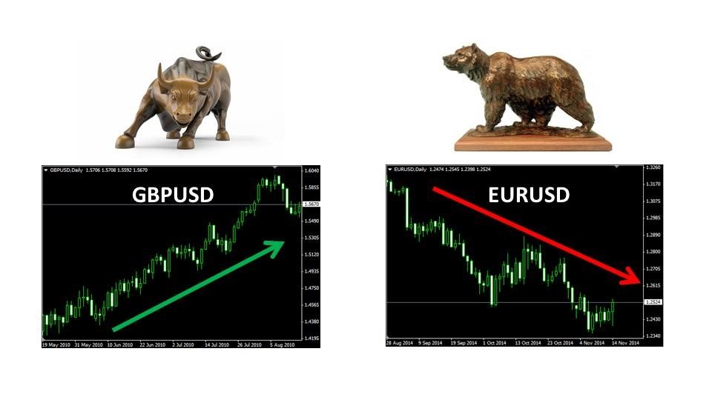

Let’s take look at how a bull can benefit from buying on the Forex Market. The next graph illustrates an upward trend. Let’s assume a bull trader bought at 1.4400 price (1.4400 USD per 1 GBP) expecting the price to rise.

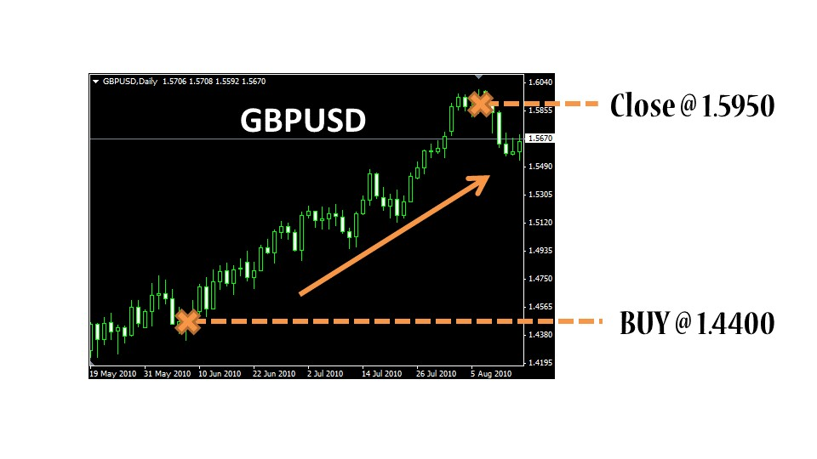

In effect, the market rose, the trader waited for some time and then closed the transaction at 1.5950. So this bull trader made money from the forex market by buying at a low price and selling at a higher price.

The mechanics of the transaction are explained by the following graph, assuming the trader invested initially an amount of $1,000 USD, buying 694 GBP at 1.4400 price. When the price rises at 1.5950, the trader exchanges the 694 GBP for $1,107 USD, obtaining a $107 profit.

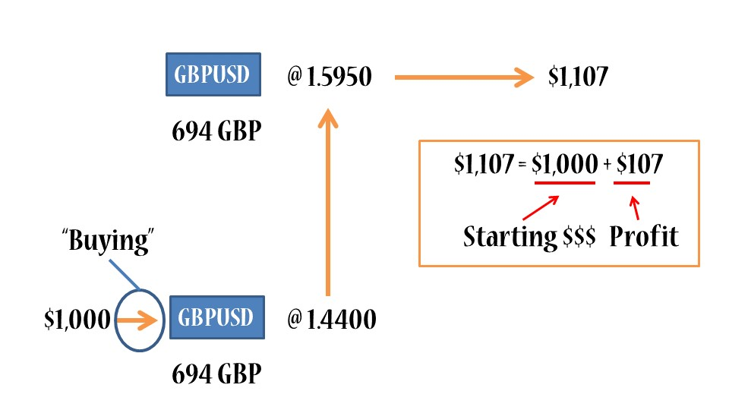

At this point you may be wondering… OK I understand the mechanics, so when I can trade? Is the Forex Market open 24/7?

A closer look at the Forex Market Hours

The following global map illustrates the main Forex Sessions and the correct way to read it is from right to left. There are 4 main Forex Sessions, first we have the Sydney session, 2 hours later we have the Tokyo session, then the London session and finally the New York session.

When should you trade? It depends on the currency pair and the strategy that you have. From the map, you can see that when New York opens, the European session is only half-way through. This is represented by a large amount of money in the market (or liquidity). Most major pairs are traded in the combination of this sessions, which means that a lot of opportunities for traders can emerge in that period of time.

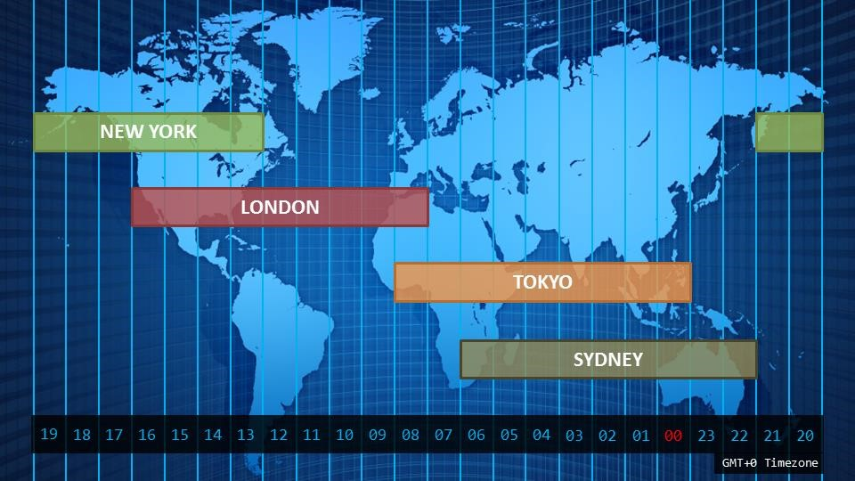

The link below is a little gift from us so that you may download the Forex Hours Map adapted to your own time zone:

[www.forexboat.com/forex-market-hours](http://www.forexboat.com/forex-market-hours)

Now that we have reviewed the basic concepts of the Forex Market, it is time to learn the Forex Language.

First of all, let’s get clear with prices: Bid and Ask…

When you go on vacation out of the country, you usually need to exchange your home currency for the currency of the country you are visiting. Then when you return, you need to exchange back the excess currency from the country you visited. This is done at an exchange booth where you are quoted a price depending on your transaction.

The same principle applies to the Forex Market, where you have an Ask price and a Bid price. If you want to buy a currency pair, then you will be quoted at the Ask price, which is always higher than the Bid price. This is the price that you will be quoted in case you want to sell the currency pair.

Let’s clarify this with the following example with the pair GBPAUD. if you want to buy GBP you will be using the Ask price and you have to pay 1.8873 AUD. However, if you want to sell GBP you will get 1.8866 AUD in exchange at the Bid price.

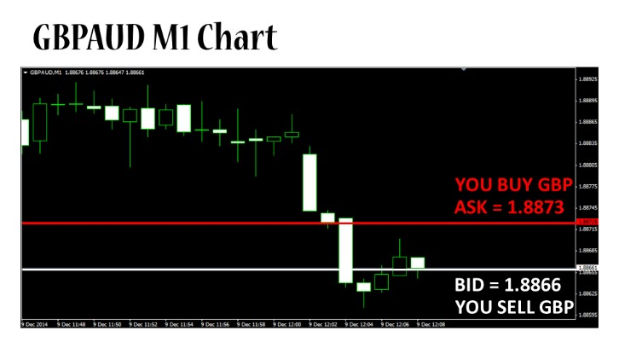

But what is that space between the Ask and the Bid? … That, my friend, is called the Spread or the cost of doing business in the Forex Market.

Spread is simply defined as what you pay for carrying out a transaction. For the example above, let’s take a look at how can we calculate the spread.

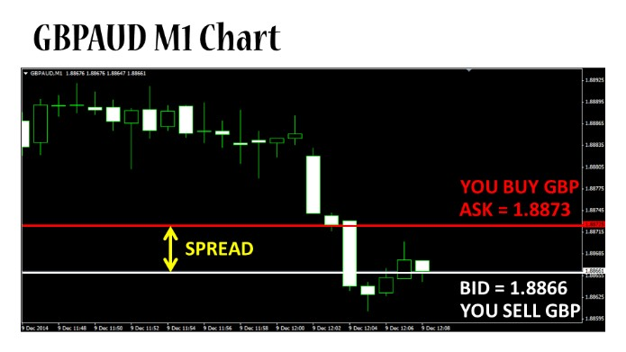

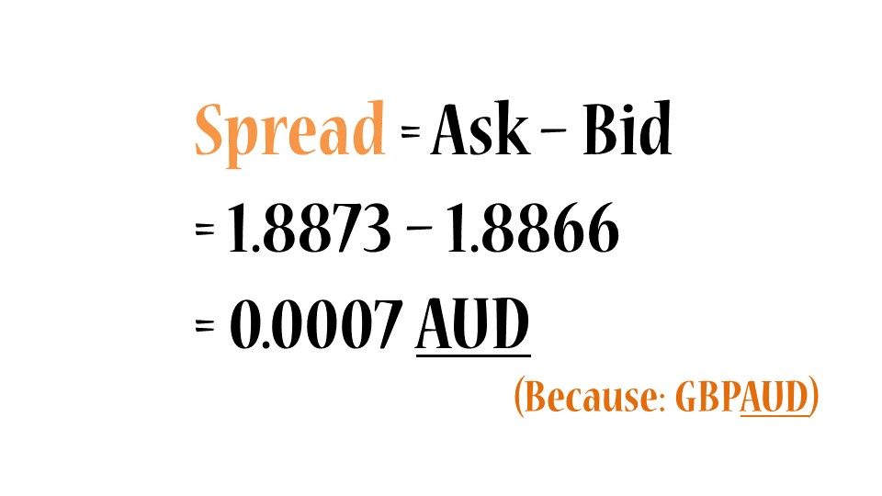

Hmmm interesting… but you may be wondering about those decimals. This complexity can be simplified by understanding Pips and Points.

Let’s consider first the 4-digit quotation system:

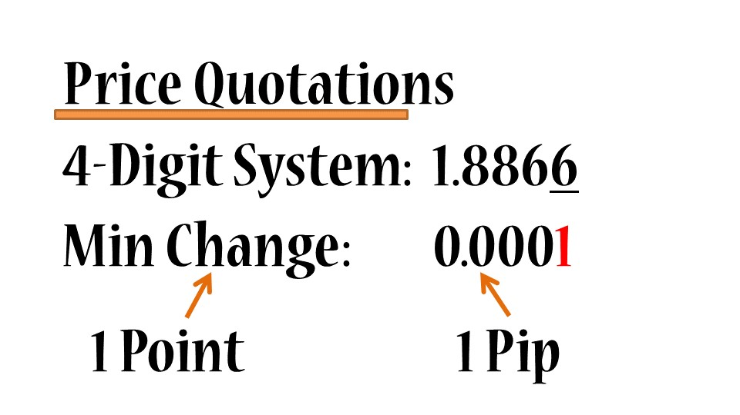

Any currency pair has 4 digits after the decimal point (except for Japanese based currency pairs). The last digit is called the minimum change, so the minimum change a currency pair can experience is 0.0001 units of quoted currency. This minimum change receives the name of 1 Point and the value (0.0001) receives the name of 1 Pip. Therefore, in this case 1 point is equal to 1 Pip.

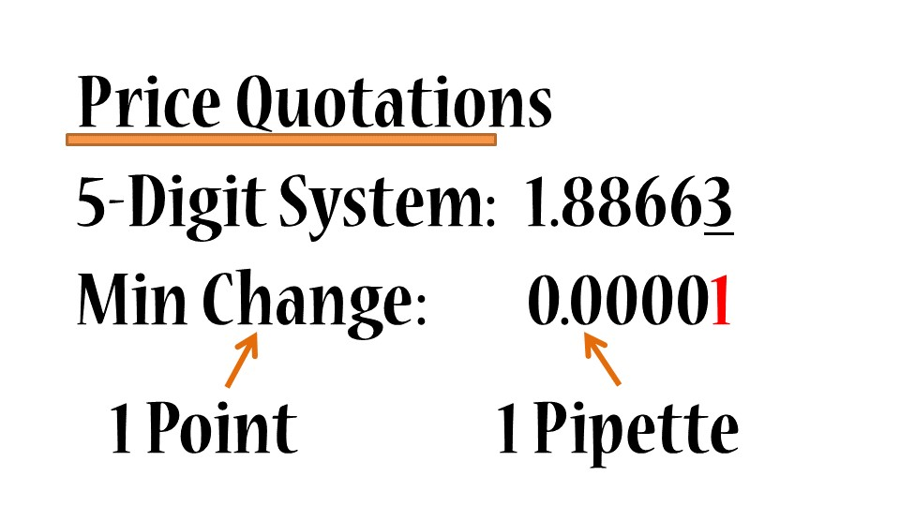

Now let’s talk about 5-digit quotations (which are more precise). Now, the minimum change that this currency pair can experience is 0.00001. The minimum change is still called 1 point, but the value on the right is labelled now with name Pipette. In this case, 1 point is equal to 1 Pipette.

Now that all the definitions regarding quotations are clear, let’s talk a little bit about volume, or in other words the quantity of measure used on the Forex Market. This point is where the concept of Lots and Leverage becomes relevant.

The graph below illustrates the different measures of volume through which we can operate on the Forex Market:

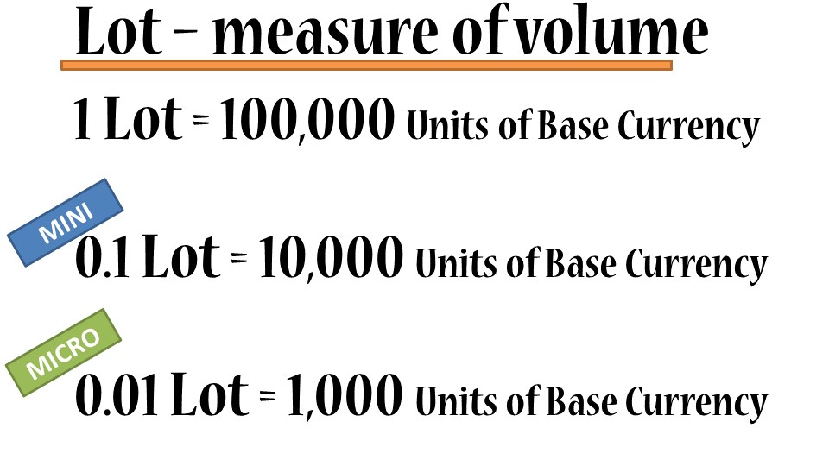

Let’s take a transaction with EURUSD as a reference. Suppose we want to buy EURUSD because we saw an opportunity in an upward trend. We want to conduct this transaction with the volume of 1 lot, that means we will be buying 100,000 Euros. The Ask price currently given by the Broker is 1.23228, this means we will need 123,228 US dollars in our account.

*Wait! That is a lot of money!*

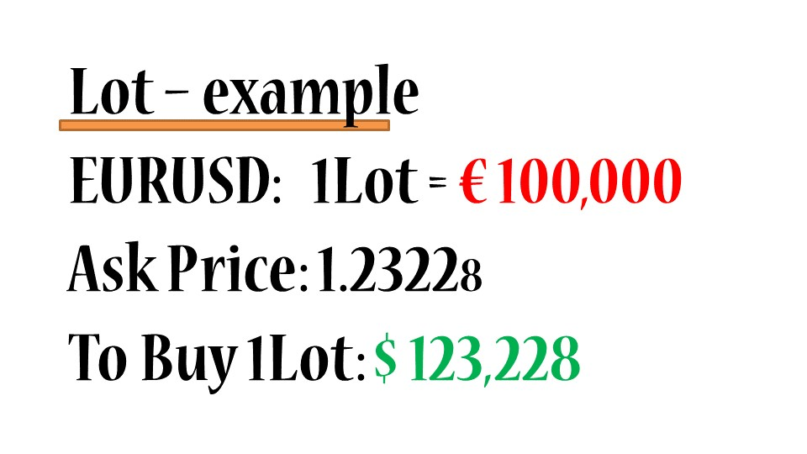

How can we still trade on the Forex Market?

*Relax, my friend, here comes Leverage to the rescue.*

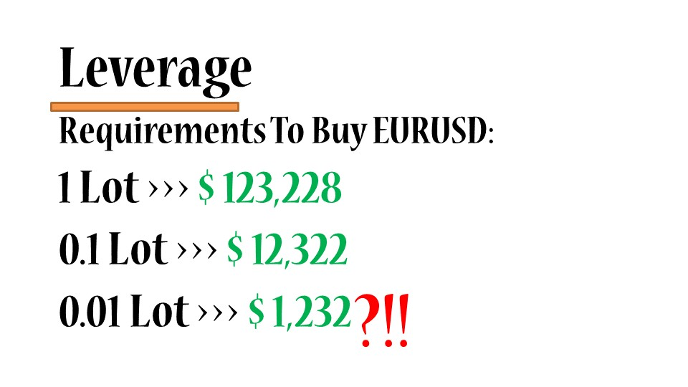

As we can see in the example above, the requirements to buy EURUSD are still very high. This is when

Leverage comes into play. The concept of Leverage has a very bad reputation and I want to clarify that Leverage is not a bad thing, if it is used properly. In simple terms, Leverage allows your Broker to lend you the money for you to conduct transactions on the Forex Market. Let’s make this clearer with the next example:

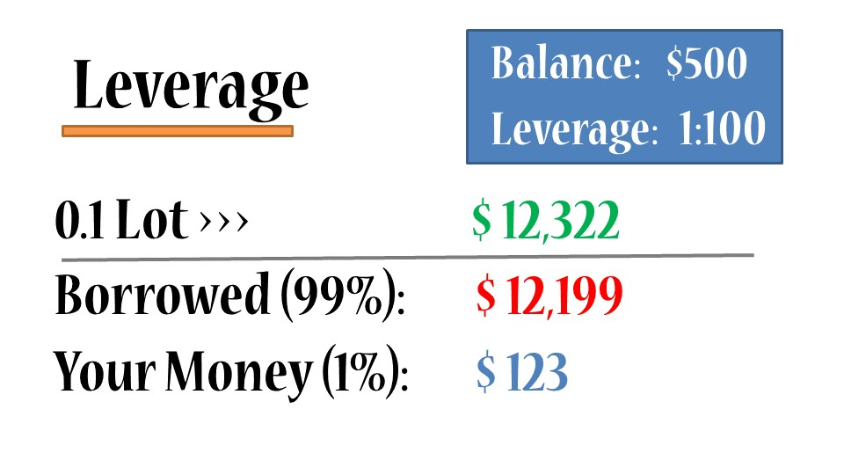

You have 500USD in your account and you want to conduct a transaction with the volume of 0.1 Lot, so in theory you would require 12,322USD to conduct the transaction. With Leverage (1:100 in this example), the broker will lend you 99% of the amount required to do the transaction, while the remaining 1% will be invested from your balance, which represents 123 USD, (which is way more affordable).

At this stage, you might be wondering if you can win or lose it all in the market, which is understandable. Let me go through the concept of StopLoss and TakeProfit, which can help us in the Forex Market when Stopping Losses or Taking Profits.

The example below illustrates when you have a rebound in the market and you expect it to go all the way up and you decide to open a Buy position. A Take Profit is an additional order which you can aggregate to your initial order, specifying that if the price reaches a certain level, then you want your Buy order to be automatically closed so you can secure a profit. If the price passes the Take Profit level, your order will therefore be closed automatically.

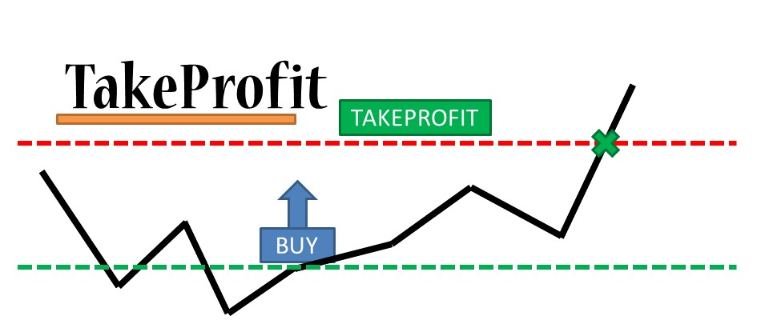

The opposite situation is shown in the example below. In this case, you expect a downward trend and therefore you want to open a Sell position. You can also embed a Take Profit to automatically close your position when the price passes the pre-defined level.

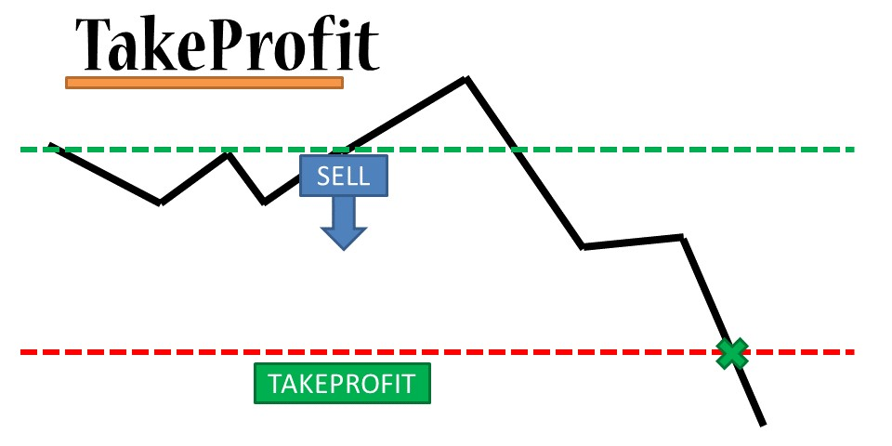

But you might be wondering what happens if something goes wrong and the price turns unexpectedly in the opposite position…. Well, that is why you must use a StopLoss.

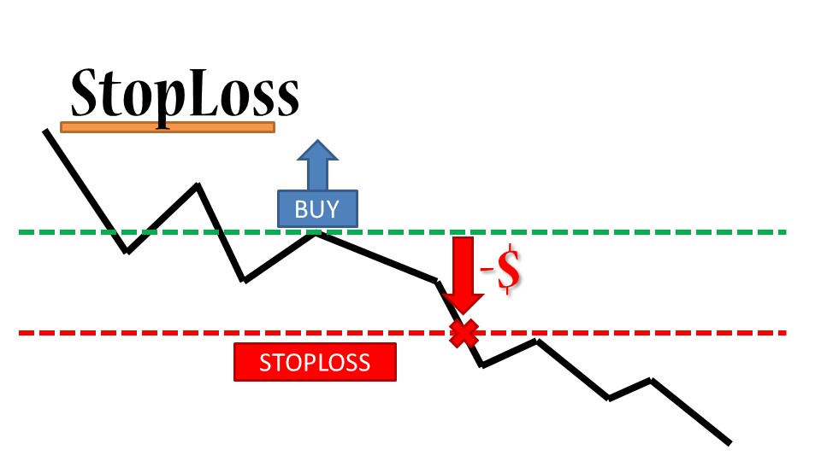

Similar to the TakeProfit, the StopLoss is also an embed order that you can attach to your Buy or Sell order with the goal of limiting the losses in case the price goes in the opposite direction. If the price passes the StopLoss level, the order should automatically be closed, bringing you a loss BUT preventing you from substantial losses. If you don’t put a StopLoss, your losses can be much greater and drain all the funds from your account. However, in the Forex Market there is always an inherent risk and most brokers do not provide a guaranteed stop loss. In addition, Stoploss may not be able to protect investors if there is a black swan event.

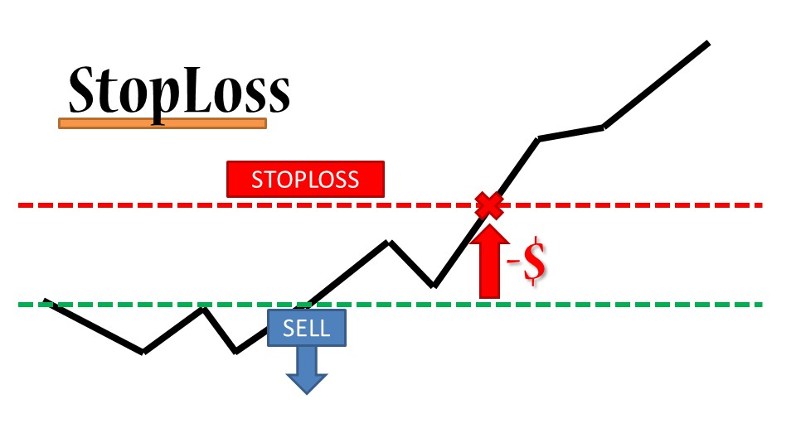

So far, we have seen the most important structural aspects of the Forex Market, the notions of reading the charts and the basic requirements of Forex Trading. The next point that we will cover is the Forex Analysis, which will provide a general idea of how to take advantage of the Forex Market.

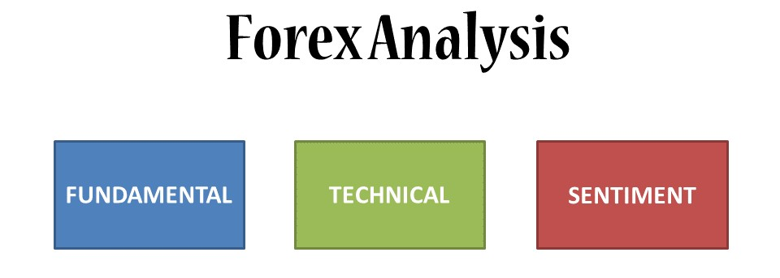

The three types of Forex Analysis are represented in the graph above. The most important aspects and related tools are explained below.

**Fundamental Analysis:**

This type of analysis is based on the belief that somewhere, out there in the world, there is information or knowledge that is not yet reflected in the market price. Traders that practice this kind of analysis think they can take advantage of the market by entering into the right position whether it be Buy or Sell.

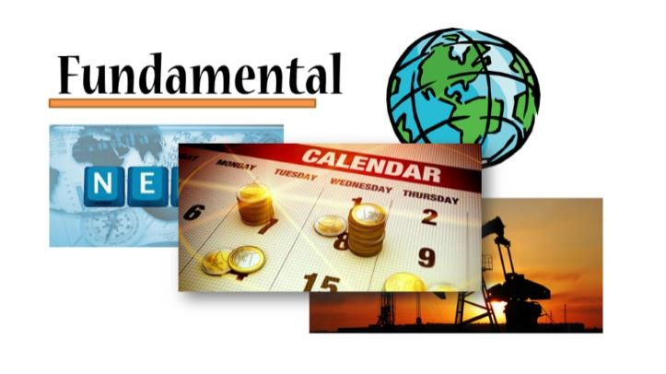

Fundamental Analysis includes reading and understanding news surrounding certain currencies, understanding the global economic climate and what happening in the world to affect the performance of a particular currency. It also involves understanding the current situation of resources (such as oil) because certain currencies correlate with the prices and supply/demand of resources.

A convenient way of doing this kind of analysis is through an economic calendar, which summarizes what is happening in the world. However, it is also advisable that you do your own research.

Please take a look at my webinar on the Economic Calendar to expand your knowledge on this subject: [Webinar on Economic Calendar](http://app.webinarjam.net/login/18872/631d785229/0/replay)

**Technical Analysis:**

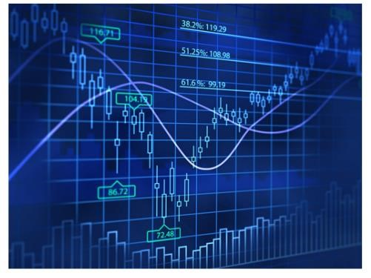

This type of analysis is based purely on the belief that all available information in the world is already contained in the price. Therefore, all you need to do is analyze the charts with no need to analyze news or interest rates of the countries, etc. Traders who believe in technical analysis think that prices move in trends and that historical patterns tend to repeat. This is how they proceed to take advantage of the market by opening a position.

Here we will take a look at the main technical analysis tools used by traders:

Trends and Flats:

One of the most common things in the Forex Market is a trend, so let’s try to understand what a trend is:

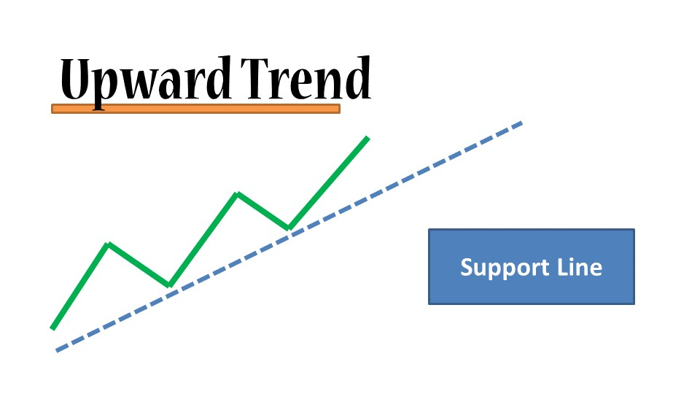

The above graph illustrates the action of a price (green line) and you can see that we can draw a blue line beneath the price. The blue line is called the support line and it indicates an upward trend and it means the price is bouncing upwards and it is continuing in an upward movement. You can therefore expect that the price will come back again, hit the support line and bounce off and keep moving upwards. A technical trader can take advantage of this by setting a Buy position, expecting the price to continue going up.

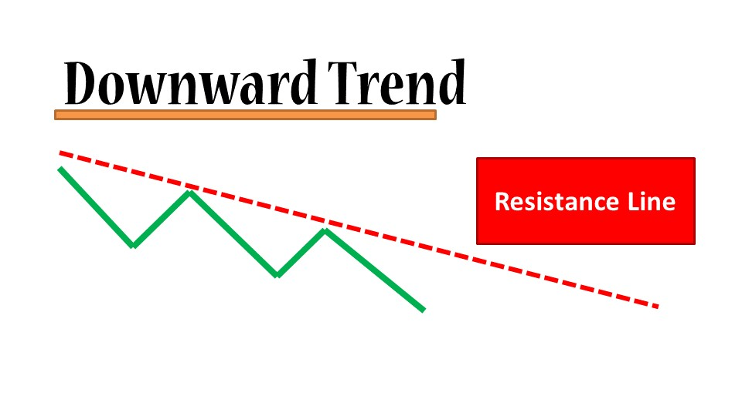

The above graph illustrates the opposite example, where the price is going down and if we draw a red line above the price, this one seems to be forced to go down. The red line is called the resistance line and you can expect the price to continue to go down if it approaches the resistance line, bouncing off downwards. Therefore, a technical trader can take advantage of this by setting a Sell position in the Market.

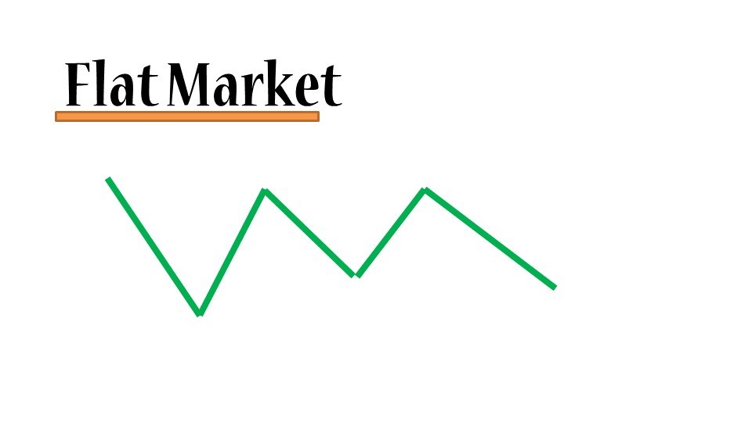

The third type of market is a flat market. In this case we cannot draw a support or resistance line because the market is moving sideways.

Channels:

We can complement a support line by drawing a channel (graph below), by copying the line and putting it above the price (green line). As you can see here, the price seems to be bouncing off downwards against the top blue. The price seems to be going through a channel or corridor. We can anticipate that if the price is going up, then it may be bouncing down again (dotted-line) and when it reaches the support line it may be a good time to set up a Buy order. There is a high probability that it will bounce against the top line again and the price level marked with the X might be a good point to close the position or set up a take profit.

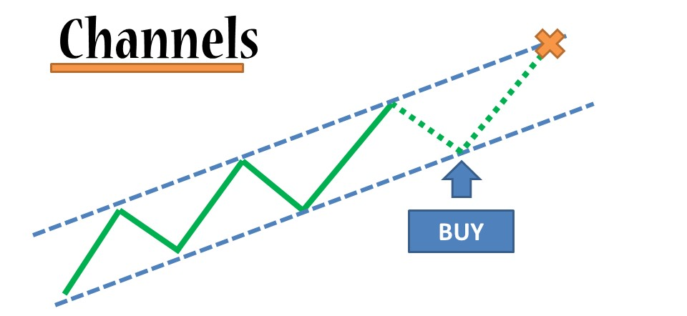

In the case of a downward trend (graph below), we can do the same process by copying the resistance line and putting it below the price. In this case we would expect the price to come up and hit the resistance line again. We can then open a Sell order to close our position or set up a take profit in price level marked with the X.

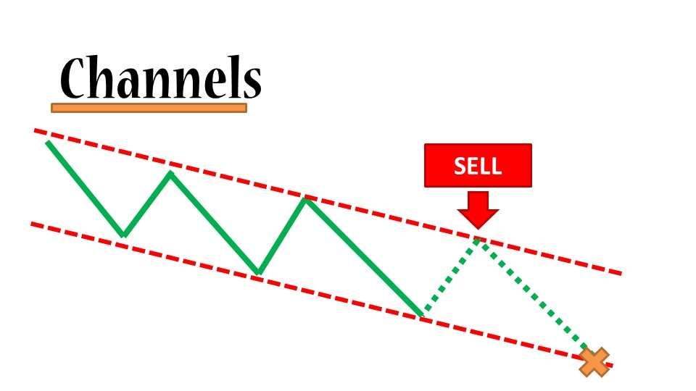

Triangle Pattern:

The triangle pattern is a very powerful but at the same time a simple formation on the Forex Market. If we take a look at the following example we can see how if we draw 2 lines (yellow lines), above and below the price line, the price seems to move in a triangle formation. The price movement decreases in its movement range and reaches a point where it cannot move anymore inside the triangle, which is exactly when the price shoots up (it can shoot down as well). This shooting represents an opportunity to set up a Buy position and profit from the upward movement in the market.

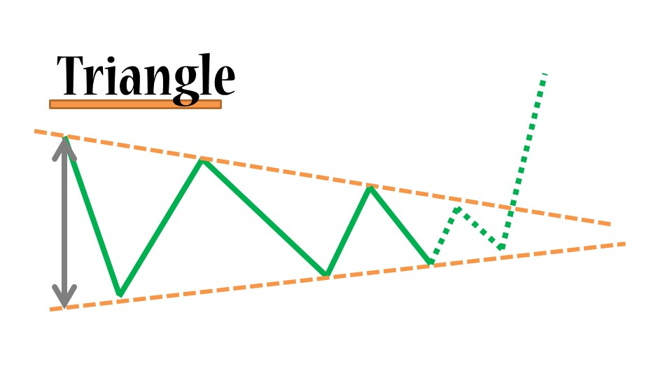

Sentiment Analysis:



Personally, I think sentiment analysis is valuable but not substantial enough to be a stand-alone type of Forex Analysis with which you can make reliable decisions. Sentiment analysis is more of an auxiliary which you can add to your analysis to make it more robust.

Sentiment Analysis implies an understanding of the general mood in the market: what traders are thinking and what their expectations are. A good starting point for that is Twitter and Facebook. You can go on Twitter and search for the currency pair you are planning to trade and see what people are saying and what they are expecting. Or you can go on Facebook, where you can find certain groups or circles talking about the Forex Market. Why is this important? Well, at the end of the day many people make transactions on the market and it matters what people think. This is especially true when ideas become viral and spread across social media networks which can influence a particular currency pair to go up or down.

Once again, it is important to highlight that it is rare that the market moves on pure sentiment, but it is a good idea to assess it and keep it in the back of your mind.

I hoped you have enjoyed this book on the Forex Market basics. Remember this is just the first step in your journey of using Forex Trading as path for additional income or to achieve financial freedom.

Just before you go…

I would like to show some gratitude for your time - reading this book and showing commitment to your learning process. I would like to invite you to join my Forex Trading Academy, where you will find great courses on the most important topics involving the Forex Market, a rich community of Forex Traders sharing their passion and opinions as well as monthly webinars where you can share your questions and doubts and see how I implement all the theory into real-action.

See you in Class!

Kirill